
2026
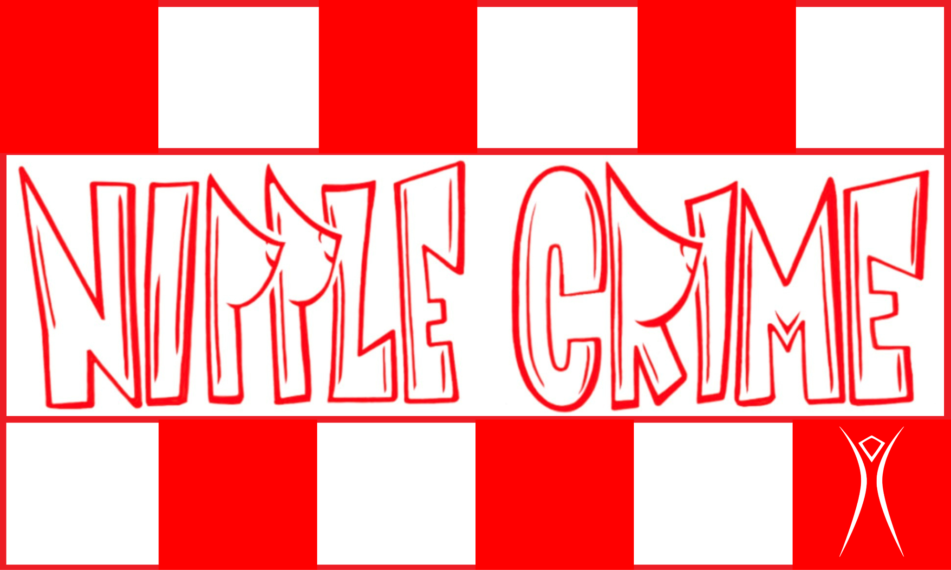
Events Coordinator Committees

Lisa Lynch

Chain of Command: Reports to the Committees Director. Oversees Events Committee Lead.
Job Description: The Events Coordinator is responsible for membership signups to accomplish the camp-wide tasks, activities, and special events. Additionally they will be the point of contact for coordinating DJs to play at our Bar and the Art Car.

Responsibilities:
- General Membership Signups
  - Early Arrival Build Crew
  - Tweaker Teardown
  - Art Car Driving & Spotting
  - Bartending
  - Kitchen Staffing
  - Fire Poofer Operation
- DJ Scheduling
- Camp Photography
  - Document Events
  - General Membership Photo Board
- Additional Special Events
  - TBD

